To: Brokers-In-Charge, Beaufort-area REALTORS©
From: The Broad Street Neighborhood Association
Date: March 17, 2008
Re: NEW UNIFORM REAL ESTATE SIGNAGE REQUIREMENTS, BROAD STREET SUBDIVISION, BEAUFORT SC 29902

Greetings from the board of the Broad Street Neighborhood Association!

Effective immediately, the only type of real estate signage allowed within the Broad Street Subdivision, including existing homes at 1301-2700 Broad Street in Beaufort, will be the “Broad Street Neighborhood Sign” available at Spectrum – The Graphic Arts Center, located at 196 Sams Pt. Rd., Beaufort, SC 29907; Ph. 843-525-0606; Fax 843-525-0501.

These white-lettering-on-green-background signs (sample picture below) are to be used for all (sale, lease, rent, or anything else) listings in the Broad Street neighborhood. They are designed to be placed on stands in the ground 3 – 6 feet from the sidewalk, between and parallel to the house being marketed and the street running in front of it.

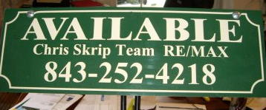

This is now the only kind of real estate signage permitted in the Broad Street subdivision.

Only one sign per house. If you or any of your agents have an existing sign in the Broad Street subdivision, please replace it immediately with the “BROAD STREET NEIGHBORHOOD SIGN” described above.

Thank you for your cooperation and support.

Sincerely,

The Broad Street Neighborhood Association Board

